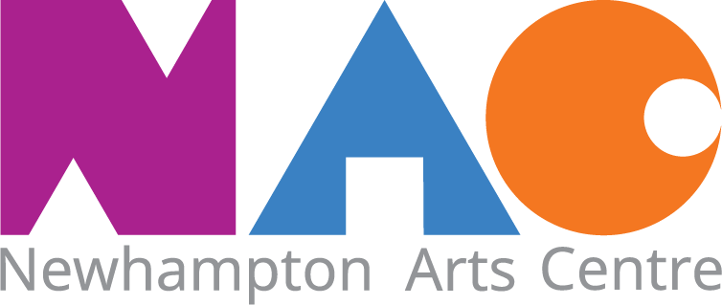
Temporary Assistant Stage Technician For The New Horizons Marquee - Summer 2022.
Job Role:
To ensure the efficient and safe operation of all the technical aspects within the temporary New Horizons marquee located within the courtyard at Newhampton Arts Centre.
Responsible to:
The technical manager.
Duties:
- Assist the setup and the day to day running of the New Horizons stage, including setting up and packing down the power distribution, PA, lighting, seating layouts.

- Become familiar with the staff team and the New Horizons stage plan, including the different layouts and requirements for specific events, i.e. music, theatre and festivals.

- Manual handling as part of a team, setting up the equipment for an event and preparing the marquee for safe operation.

- Operating the audio and lighting consoles, under supervision, during events with the potential of some creative freedom while learning new skills and developing existing ones through working with local and national artists and performers.

- Setting up the equipment on stage ready for the performance, i.e. running cables and microphones.

- Maintaining the work areas to ensure the safety of the team and general public.

- Liaise with visiting artists, promoters, clients and staff on the day to ensure all events are delivered to the highest standards and according to their requirements.

- Be responsible for site health and safety issues and security
- Give assistance and information to visitors
- Act as a representative for NAC during work hours
Mentoring and training
There is a strong on-the job training aspect to this role. We are not expecting someone to arrive with a complete skill set for end to end technical assistance. The role will be supported by experienced staff within the NAC team who have decades working in technical and event management positions. You will work directly with the technical manager and the rest of the technical team.
Period of employment
We plan to appoint the New Horizons technician as soon as possible, work would commence from Monday 25th April. The New Horizons stage itself will be operational at the start of May launching with a folk music event.
The New Horizons stage will be up until mid-September and the contract will be completed by the end of September 2022.

Personal Specification
Required:
- Confident, responsible and calm in dealing with the public
- Consistency in applying policies and procedures at all times
- Ability to work as part of a team
- Reliable time-keeper
- Ability to handle standard IT systems such as email, electronic POS systems etc. (training will be given on the specific systems used at NAC).
- Interest in the live events, arts and cultural sector

Terms and conditions
This is a flexible hours contract and the actual hours offered will be according to the needs of the business and may vary from week to week.
These hours will be worked from 8:30am – 12:00 pm Monday-Sunday as required.
Evening and weekend work will be required.
The employer will guarantee a minimum of 350 hours (including paid holiday) across the length of the contract.
Salary
The current hourly rate for this role is £9.78 per hour.
a. Wages will be paid monthly by Direct Payment into a named bank account.
b. Newhampton Arts Centre will pay Employer’s National Insurance Contributions.
c. Tax and National Insurance, plus any other statutory deductions (including student loan repayments), will be deducted at source.
d. Pay is reviewed annually in April of each year and the above hourly rate includes the rise from 1.4.22.
3. Pension: An auto-enrolment pension scheme is in operation with The People’s Pension. Current contributions are 3% for employer and employee.
4. Holidays: 25 paid days per year, pro rata plus statutory holidays, and including Christmas and New Year site closure days. Holidays must be taken at times convenient to the running of the NAC.
5. Training: Appropriate training will be provided as necessary.
6. Probation: This contract is conditional on a satisfactory probationary period of one month.
7. Sick Pay: Absence due to sickness must be notified by 9am on the first day or as soon as possible.
8. Grievance and Disciplinary Procedures will be dealt with by Line Manager and then the CEO in the first instance. If necessary, matters can be referred to the board members responsible for staff Issues.
9. Termination of contract: Four weeks’ notice of termination of contract is required on either side.
10. Security: The Employee will be responsible for looking after keys and security codes entrusted to them and will not pass these on to any unauthorized individual
11. Staff Handbook: Full conditions of employment are available in the NAC office.
12. Any offer of employment is conditional on an Enhanced Disclosure and Barring Services check.
13. NAC reserves the right to require all employees to follow specific public health guidance that may be issued by either national government or the local authority.
To Apply.
Email NAC for an application form on office@newhamptonarts.co.uk and return it to us completed by 9:00am on the 14th April.
Shortlisted applicants will then be invited to interview on Tuesday 19th April.
Please ensure you are free on this date if you do apply.
For any queries please contact office@newhamptonarts.co.uk
We aim to make a decision as soon as possible after this date.

Diversity statement:

NAC is committed to building a more diverse and inclusive workplace, and encourages applications from candidates of all backgrounds, identities and lived experiences. We aim to make both the application and interview process, and the role itself, as accessible as possible. If you have any particular needs at any stage in the process and wish to discuss in further detail, please contact office@newhamptonarts.co.uk

Want a chat?
Please email Chris Brown (Site Manager) on cefnbrith@googlemail.com for an informal chat about this role.

Newhampton Arts Centre, Dunkley Street, Wolverhampton WV1 4AN
Registered Charity No: 1066687 Registered Company No: 3340600
admin@newhamptonarts.co.uk
www.newhamptonarts.co.uk

